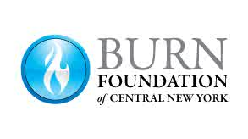

As you pack for camp…

Clothing and Equipment Check List:
Remember that camp is a place for exploring and playing hard. Campers need enough outfits for four days of camp and should be able to get wet and dirty without undue concern for clothing.

 | Underwear |  | Towels (2) & Washcloth
 | Socks |  | Soap & Shampoo
 | Shorts |  | Toothbrush & Toothpaste
 | Pants/Jeans |  | Brush/Comb
 | Shirts |  | Sleeping Bag/sheets/blanket
 | Sweater/Sweatshirt/Jacket |  | Pillow
 | Sneakers |  | Rain Gear
 | Swim suits |  | Water shoes, Crocs, or flip flops
 | Pajamas |  | Sunscreen & Insect Repellant

Optional Items:
The following items are things that may enhance your week at camp.

Flashlight with Fresh Batteries
Water Bottle
Backpack
Camera
Anything that will remind you of home (stuffed animal, etc.)
Anything Hawaiian!

Note: There is limited cell phone coverage at camp, so you may want to leave yours at home.

Please Leave the following items at Home:
- Video Games
- Radio/CD/MP3/iPods
- Money
- Expensive Clothing/Valuables
- Weapons
- Inappropriate Clothing
- Food/Drinks/Candy
- Alcohol/Drugs/Cigarette
- iPad/ Kindle/ Nook

